1 UID0-000-001 – TSDS UID Presumed Duplicate Student Report for Enrollment
The Presumed Duplicate Student Report provides a listing of presumed duplicate student events. An event is an individual student’s enrollment to or withdrawal from a Campus ID of Enrollment tightly coupled with the date the enrollment or withdrawal event took place.

Report Inclusion
To be included in this report:
    - Only the last two enrollments (enroll/withdraw type = 01) will be considered and the oldest of those events must be at the reporting LEA.
    - It should provide a list of all students who are enrolled at the reporting LEA/campus during the school year and also have an enrollment recorded at another LEA/campus with an enrollment date equal or greater than the enrollment at the reporting LEA/campus.
    - One of the following combination of conditions should be true:
      - Late Withdrawal Event - The student has a withdrawal event from a Campus ID of Enrollment and a subsequent enrollment event to a second Campus ID of Enrollment with a withdrawal date from the first Campus ID of Enrollment that is greater than the enrollment date at the second campus, OR
      - No Withdrawal Event - The student has enrollment events at two different Campus IDs of Enrollment without a withdrawal between the two enrollment events
      - For example:
        - The student enrolls at Campus 2 on September 1st, 2020 and withdraws from Campus 1 on September 2nd OR
        - The student enrolls at Campus 1 on September 1st, 2020 and enrolls at Campus 2 on September 2nd, 2020

Content
This report will show:
    - Student Name – Student name in alphabetical order by last name (Last, First Middle)
    - Unique ID – Unique identification number that identifies the student in the Texas Student Data System (TSDS) Unique-ID system
    - Local ID – Optional LEA-assigned identification number for the student
    - Student ID – Social security number or state-approved alternative identification number that identifies the student in the TSDS Unique-ID system
    - Date of Birth – Student date of birth
    - LEA ID – County-District identification number followed by the name of the LEA identified with the event
    - Campus ID – Last three digits of the campus County-District identification number followed by the name of the campus identified with the event
    - Verified Flag – Optional Event flag indicator designating the correct enrollment in a duplicate enrollment situation.
      - V (Verified) – dual event dates have been verified or validated by some other means of documentation.
    - Enroll/Withdraw Type – Type of event:
      - 01 – Enrollment
      - 02 – Withdrawal

    - Enroll/Withdraw Date – Date the event occurred (MM/DD/YYYY)
    - Total Presumed Duplicate Enrollment Students for Campus – Total distinct count of students for the campus presumed to have duplicate enrollment based on the conflicting occurrence of two or more ET events.
    - Total Presumed Duplicate Enrollment Students for LEA – Total distinct count of students for the LEA presumed to have duplicate enrollment based on the conflicting occurrence of two or more ET events.

Parameters
Report users may run the report with different parameters to generate the desired results. Campus users may choose to display the entire Student ID if desired.
LEA users may choose:
    - To display the entire Student ID if desired
    - One, multiple or all campuses to display

Mock-up
LEA-level
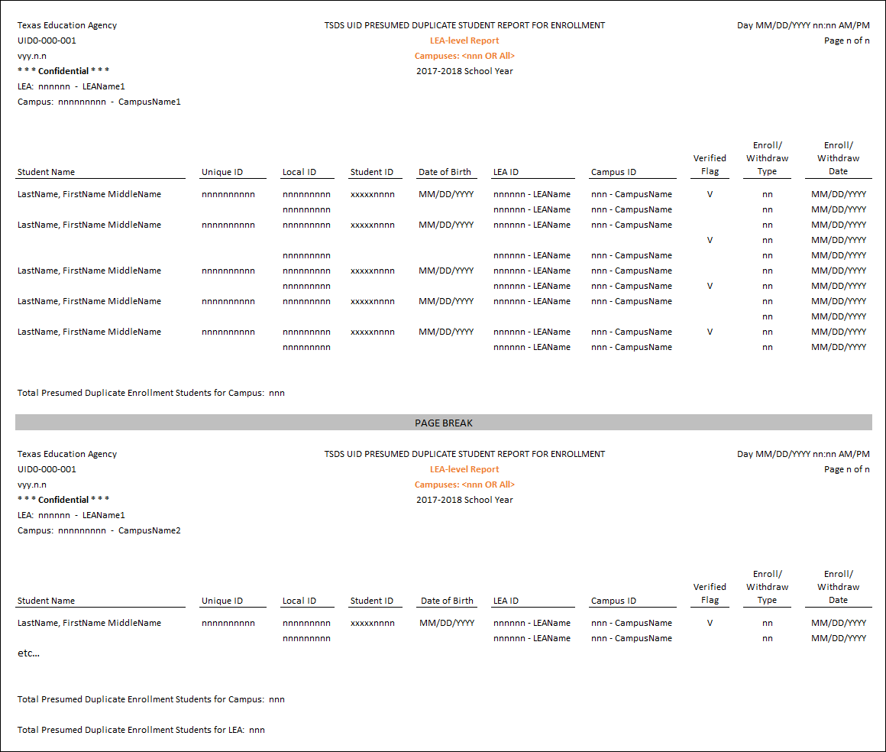

2 UID0-000-002 – TSDS UID Students Showing Withdrawn
This is a school-year based, point-in-time report that displays a list of all students who are enrolled at the reporting LEA/campus during the school year and also have an enrollment recorded at another LEA/campus with an enrollment date equal or greater than the enrollment at the reporting LEA/campus.

Report Inclusion
To be included in this report:
    - A student must be considered a potential mover
      - There must be an enrollment event for a student at the reporting LEA, AND
      - There must be a withdrawal event for that student at the reporting LEA, AND
      - There must be an enrollment event at a different LEA, with an event date greater than the previous withdraw date from the reporting LEA
For example:
      - The student enrolls in LEA 1 on September 1st, 2020
      - The student withdraws from LEA 1 on September 2nd, 2020
      - The student enrolls in LEA 2 on September 3rd, 2020
OR
    - A student must be considered a potential leaver
      - There must be an enrollment event for a student at the reporting LEA, AND
      - There must be a withdrawal event for that student at the reporting LEA, AND
      - There is no subsequent enrollment event at any other LEA, with an enrollment date greater than or equal to the withdrawal date from the reporting LEA
For example:
      - The student enrolls in LEA 1 on September 1st, 2020
      - The student withdraws from LEA 1 on September 2nd, 2020
      - The student is not enrolled at any other LEA as of on September 2nd, 2020

Content
This report will show:
    - Student Name – Student name in alphabetical order by last name
    - Unique ID – Unique identification number that identifies the student in the Texas Student Data System (TSDS) Unique-ID system
    - Local ID – Optional LEA-assigned identification number for the student
    - Student ID – Social security number or state-approved alternative identification number that identifies the student in the TSDS Unique-ID system
    - Date of Birth – Student date of birth
    - LEA ID – County-District identification number followed by the name of the LEA identified with the event
    - Campus ID – Last three digits of the campus County-District identification number followed by the name of the campus identified with the event
    - Enroll/Withdraw Type – Type of event:
      - 01 – Enrollment
      - 02 – Withdrawal
    - Total Potential <Movers OR Leavers> for Campus – Total distinct count of potential movers or leavers shown as withdrawn for the campus.
    - Total Potential <Movers OR Leavers> for LEA – Total distinct count of potential movers or leavers shown as withdrawn for the LEA.

    - Total Potential Movers and Leavers for Campus – Total distinct count of potential movers and leavers shown as withdrawn for the campus.
    - Total Potential Movers and Leavers for LEA – Total distinct count of potential movers and leavers shown as withdrawn for the LEA.

Parameters
Report users may run the report with different parameters to generate the desired results.
    - Campus- and LEA-users must choose to display Potential Movers, Potential Leavers or both.
    - Campus- and LEA-users may choose to display the entire Student ID if desired.
    - LEA-users must choose one, multiple or all campuses to display.

Mock-up
LEA-level – All Reports
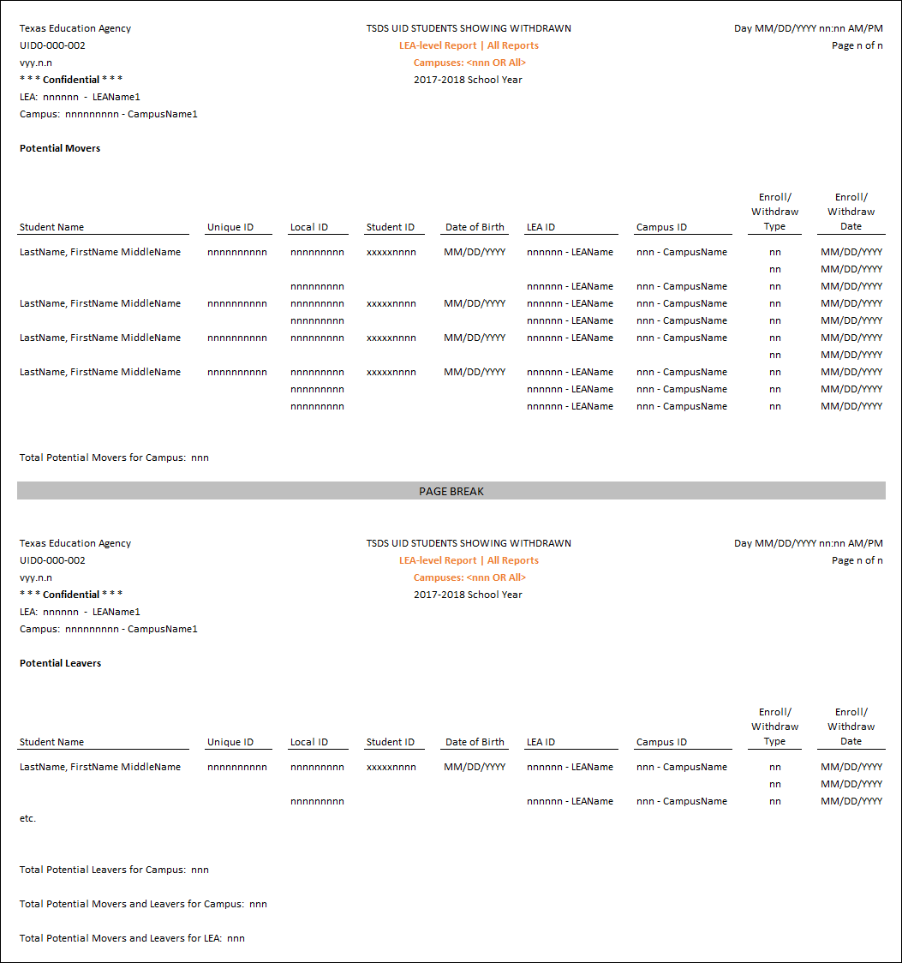

3 UID0-000-003 – TSDS UID Students Not Showing Withdrawn
This is a school-year based, point-in-time report that displays a list of students who are shown as not withdrawn and are considered potential movers or potential continuing students for the school year. All students who are enrolled at the reporting LEA/campus during the school year and also have an enrollment recorded at another LEA/campus with an enrollment date equal or greater than the enrollment at the reporting LEA/campus.

Report Inclusion
To be included in this report:
    - A student must be considered a potential mover – The student has enrolled at another campus without showing a withdrawal at the reporting campus.
For example:
      - The student enrolls in LEA 1 at Campus 1.
      - The student enrolls in LEA 2 at Campus 2
      - There is no withdrawal date from LEA 1 Campus 1.
      - The enrollment date for LEA 2 Campus 2 is greater than or equal to the enrollment date for LEA 1 Campus 1.
OR
    - A student must be considered a potential continuing student – The student is enrolled at a campus in the reporting LEA and there is no subsequent enrollment at any other campus (within the reporting LEA or another LEA).
For example:
      - The student enrolls in any campus in LEA 1.
      - There is no withdrawal from LEA 1.
      - Note: The student might have transferred from Campus 1 to Campus 2 within LEA 1; however, records would not indicate such if ET event withdrawal data is not supplied at the time of transfer.

Content
This report will show:
    - Student Name – Student name in alphabetical order by last name
    - Unique ID – Unique identification number that identifies the student in the Texas Student Data System (TSDS) Unique-ID system
    - Local ID – Optional LEA-assigned identification number for the student
    - Student ID – Social security number or state-approved alternative identification number that identifies the student in the TSDS Unique-ID system
    - Date of Birth – Student date of birth
    - LEA ID – County-District identification number followed by the name of the LEA identified with the event
    - Campus ID – Last three digits of the campus County-District identification number followed by the name of the campus identified with the event
    - Enroll/Withdraw Type – Type of event:
      - 01 – Enrollment
      - 02 – Withdrawal
    - Enroll/Withdraw Date – Date the event occurred
    - Total Potential <Movers OR Continuing Students> for Campus – Total distinct count of potential movers/continuing students shown as not withdrawn for the campus.

    - Total Potential <Movers OR Continuing Students> for LEA – Total distinct count of potential movers/continuing students shown as not withdrawn for the LEA.
    - Total Potential Movers and Continuing Students for Campus – Total distinct count of potential movers and continuing students shown as not withdrawn for the campus.
    - Total Potential Movers and Continuing Students for LEA – Total distinct count of potential movers and continuing students shown as not withdrawn for the LEA.

Parameters
Report users may run the report with different parameters to generate the desired results.
    - Campus- and LEA-users may choose to display the entire Student ID if desired.
Campus- and LEA-users must choose to display Potential Movers, Potential Continuing students or both.
    - LEA-users must choose one, multiple or all campuses to display

Mock-up
LEA-level – All Reports
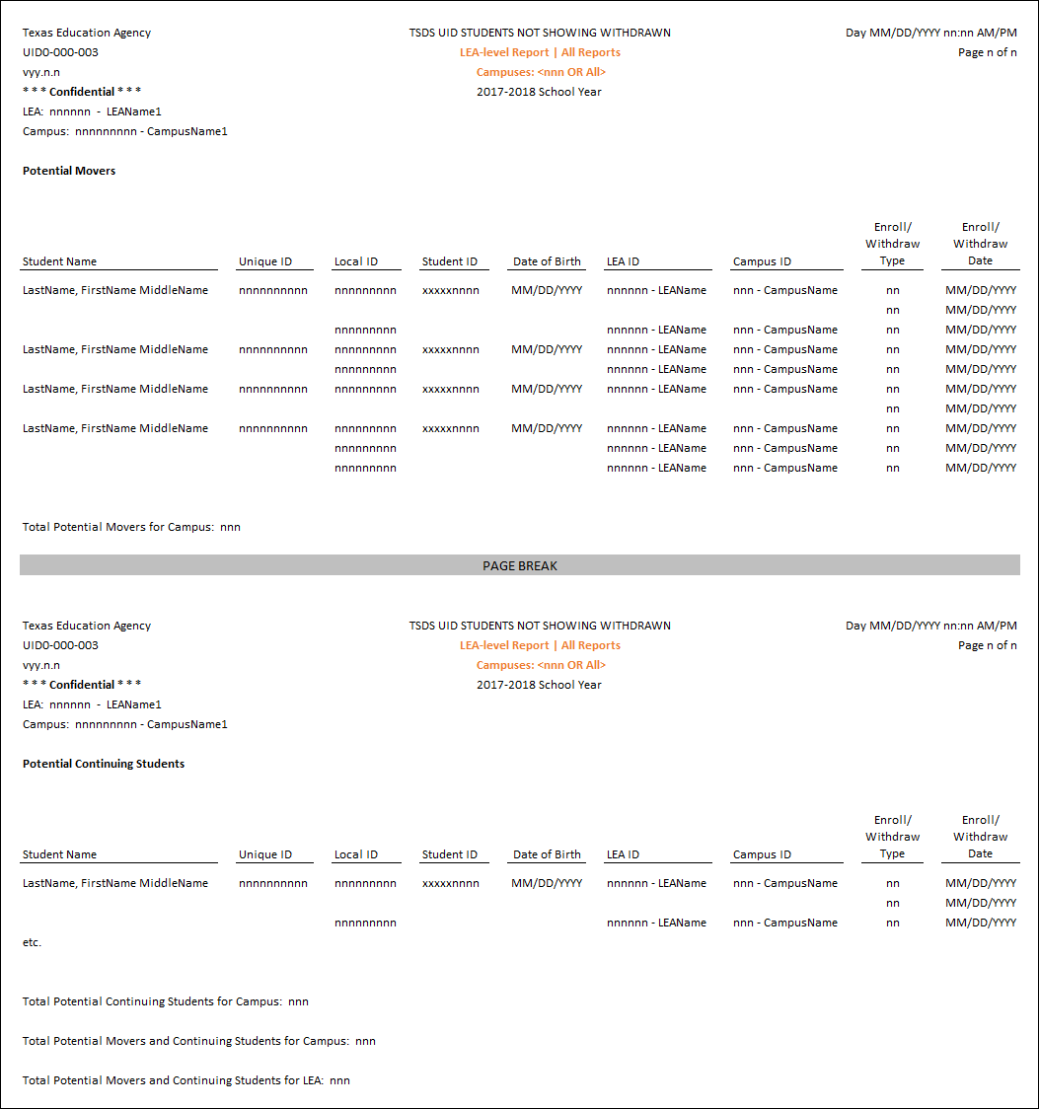

4 UID0-000-004 – TSDS UID Enrollment Status of Prior School Year Students
This is a school-year based, point-in-time report that displays current school year information for students identified as potential leavers or continuing students during the prior school year. The report assists LEAs with determining if a student in grades 7-12 should be reported as a potential leaver in the Fall PEIMS Submission.

Report Inclusion
To be included in this report:
    - It should include data from the current and prior year (August 1-July 31).
    - A student must be considered a potential leaver – if the student was enrolled at the reporting LEA at any time in the prior year, and is not enrolled at the reporting LEA during the school start window in the current year.
OR
    - A student must be considered a potential continuing student – If the student was enrolled at the reporting LEA at any time in the prior year, and is enrolled at the reporting LEA during the school- start window in the current year.

Content
This report will show:
    - Prior Year Information
      - Student Name – Student name in alphabetical order by last name
      - Unique ID – Unique identification number that identifies the student in the Texas Student Data System (TSDS) Unique-ID system
      - Local ID – Optional LEA-assigned identification number for the student
      - Student ID – Social security number or state-approved alternative identification number that identifies the student in the TSDS Unique-ID system
      - Date of Birth – Student date of birth
    - Current Year Information – Applicable to Potential Continuing students only.
      - LEA ID – County-District identification number followed by the name of the LEA identified with the event
      - Campus ID – Last three digits of the campus County-District identification number followed by the name of the campus identified with the event
      - Enroll/Withdraw Type – Type of event:
        - 01 – Enrollment
        - 02 – Withdrawal
      - Enroll/Withdraw Date – Date the event occurred
    - Total Potential Leavers for Campus/LEA – Distinct count of potential leavers shown as withdrawn from the campus during the prior school year and not showing a current school year enrollment date.
    - Total Potential Continuing Students for Campus/LEA – Distinct count of potential continuing students shown as withdrawn from the campus during the prior school year and showing at least one current school year enrollment date.
    - Total Potential Leavers and Continuing Students for Campus – Total distinct count of potential leavers and continuing students for the campus.

    - Total Potential Leavers and Continuing Students for LEA – Total distinct count of potential leavers and continuing students for the LEA.

Parameters
Report users may run the report with different parameters to generate the desired results.
    - Campus- and LEA-users may choose to display the entire Student ID if desired.
    - Campus- and LEA-users must choose Potential Leavers, Potential Continuing Students or both.
    - LEA-users must choose one, multiple or all campuses to display

Mock-up
LEA-level – All Reports
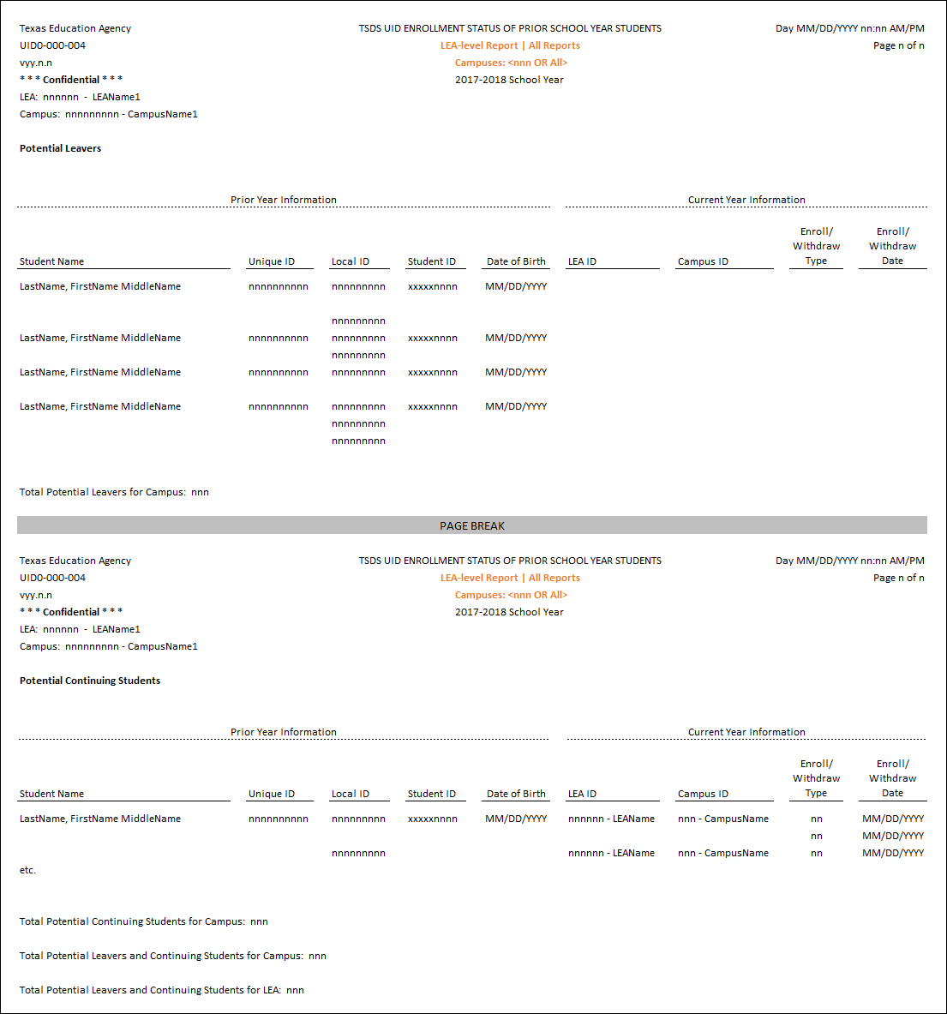

5 UID0-000-005 – TSDS UID Student Enrollment Roster Report
This report provides a detailed listing of all events for each student who has enrolled in the reporting LEA/campus during a given school year. Because the report lists all enrollment and all withdrawal events, as a school year progresses, the LEA report has the potential to become extremely long for large LEAs; for these LEAs, the report should be generated at the campus level.

Report Inclusion
To be included in this report:
    - The student must have been enrolled at the reporting LEA at any point during the school year
    - Only events for the reporting LEA shall be included
    - All events for the given LEA and student shall be included

Content
This report will show:
    - Student Name – Student name in alphabetical order by last name
    - Unique ID – Unique identification number that identifies the student in the Texas Student Data System (TSDS) Unique-ID system
    - Local ID – Optional LEA-assigned identification number for the student
    - Student ID – Social security number or state-approved alternative identification number that identifies the student in the TSDS Unique-ID system
    - Date of Birth – Student date of birth
    - Gen – Generation suffix (Jr., Sr., etc.)
    - Sex – Male or Female (birth certificate)
    - Ethnicity – Code indicating the student’s ethnic origin. If multiple ethnicities are chosen, the report should display all ethnicity codes
    - Enroll/Withdraw Type – Type of event:
      - 01 – Enrollment
      - 02 – Withdrawal
    - Enroll/Withdraw Date – Date the event occurred
    - Total Student Enrollment for Campus – Total distinct count of students for the campus.
    - Total Student Enrollment for LEA – Total distinct count of students for the LEA.

Parameters
Report users may run the report with different parameters to generate the desired results.
    - Campus- and LEA-users may choose to display the entire Student ID if desired.
    - Campus- and LEA-users must choose one, multiple or all grades to display (EE-12).
    - LEA-users must choose one, multiple or all campuses to display

Mock-up
LEA-level
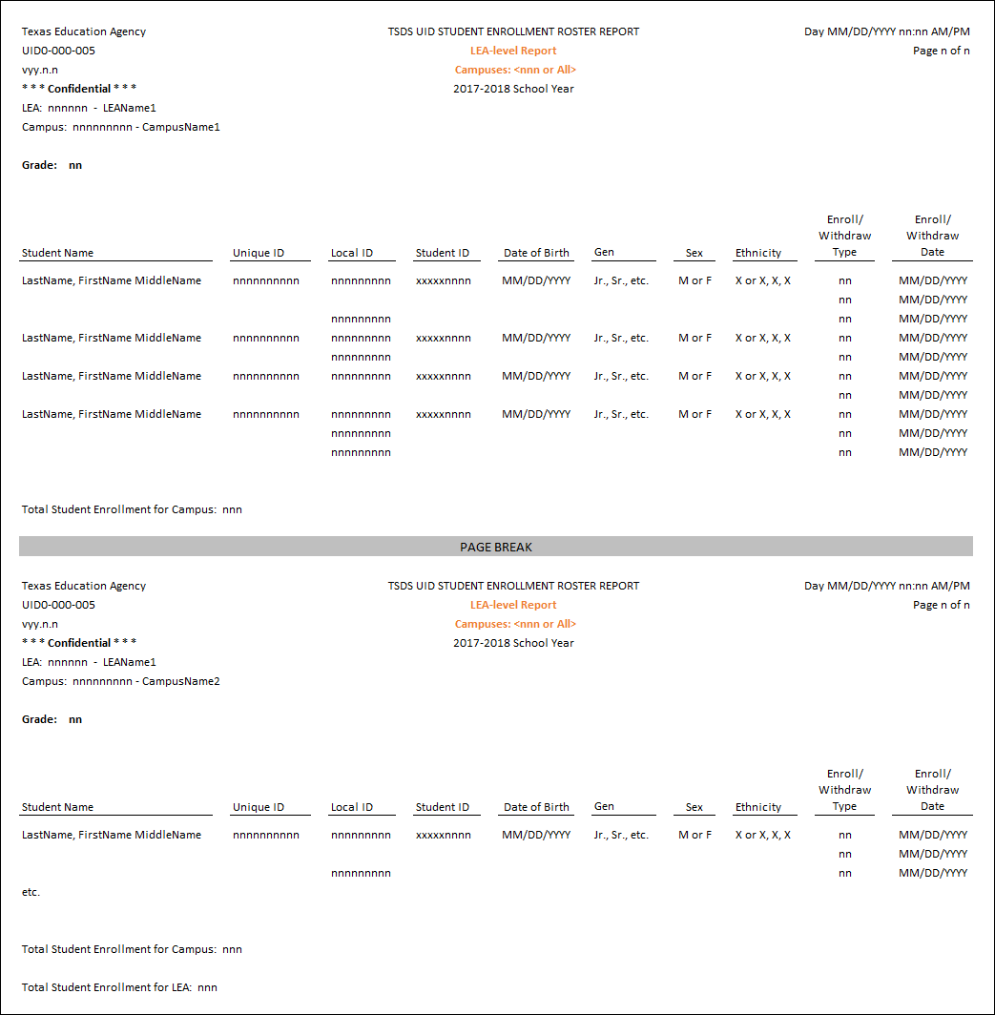

Report
UID0-000-006 – TSDS UID Missing Enrollment Event Submission
6
This is a school-year based report, generated by a TEA or ESC user, that lists all active LEAs that have not submitted ET event data during a specified date range and their last successful submission date. A batch file is a Unique ID Enrollment Tracking file uploaded into the UID system for the purpose of recording enrollment/withdrawal events.

Report Inclusion
To be included in this report the LEA must:
    - Have an active status in Org
    - Be within the ESC’s PEIMS region
    - Have not completed a successful ET event file submission (reached a downloadable state) during a specified date range

Content
This report will show:
    - LEA ID – County-District identification number followed by the name of the LEA identified with the event.
    - LEA Name – Name of the LEA identified with the ET event.
    - Last Successful Submission – Date that the LEA last successfully submitted ET event data.
    - User Name – Name of the person that last submitted ET event data.
    - Report Date Range
    - Total LEAs in Region – Total LEAs within the selected ESC
    - Total LEAs – Total LEAs listed on the report

Parameters
Report users may run the report with different parameters to generate the desired results.
    - ESC-user can run a report that displays all LEAs within their ESC that meet the report criteria
    - ESC- and TEA-users must designate a start and an end date (End date may not be before start date)
    - TEA-users must choose one, multiple or all ESCs to display

Mock-up
State-level
